

Detecting Misinformation

Author: Toby Anderson

09/17/2022
Toby Anderson
tander10@syr.edu
Final Project
Misinformation Detection
09/17/2022
Catchy Title
Introduction  10/10 | In the United States, freedom of expression is a fundamental pillar of law. This is why freedom of speech, freedom of the press, and freedom to assemble are codified in the constitution. Behind this principle is the assumption that the truth will always prevail in the “Marketplace of Ideas”. With an educated populace who scrutinize facts and statements, incorrect beliefs should eventually be rooted out.  However, the US constitution was written before the advent of the world wide web, social media, and a generally well-connected populace. New pressures have emerged in this environment that invalidate the assumption that the Truth will prevail. Now memes and ideas spread like viruses, preying on hidden biases and sometimes designed explicitly to bait clicks from users.    Figure 1 – Clickbait illustration  With this flood of information, people no longer have the capacity to scrutinize every fact that is presented to them. This leaves the public without effective coping mechanisms for determining truth from lies. Instead of investigating each fact, trusted sources are relied upon to provide truth that does not need to be verified.    Figure 2 – Trusted information sources  Relying on trusted sources leaves the public vulnerable to intentional lies. Lies which have been designed to look like news are called “misinformation”, and have become a growing problem. Tools which can create credible-looking misinformation have become more sophisticated, and the public is unable to keep up in this war of information. Misinformation can sway public opinion, impact election results, cause increasing polarization, and potentially destabilize communities.  Because the public is limited in their capacity to fact-check, they must turn to more automated assistance. By using Machine Learning, misleading articles can be flagged or completely filtered out of online social spaces. Utilizing information checking tools will be critical to support the public to improve the quality of information transfer, and re-establish trust on social platforms.

Analysis  40/40 | data DESCRIPTION  The dataset was sourced from kaggle (https://www.kaggle.com/datasets/stevenpeutz/misinformation-fake-news-text-dataset-79k). It includes nearly 80,000 training examples of genuine and fake news articles. Analyzing the entire dataset was computationally infeasible, so the data was sub-sampled to 10,000 true examples and 10,000 false examples.  The true samples contain articles from Reuters, the New York Times, and the Washington Post. The fake samples contain articles from extremist websites, and publicly available datasets used by fact-checking organizations.  Both the fake and genuine samples appear to cover mainly political topics, as shown in the word clouds below. No significant difference was found between the topics covered in the fake and genuine articles.  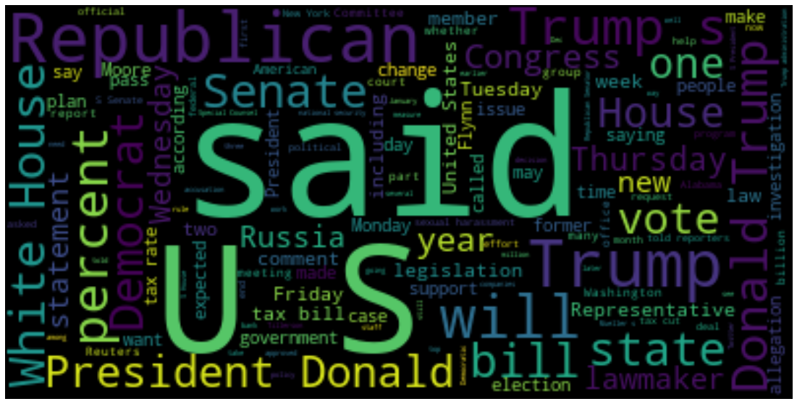  Figure 3 – True article significant terms  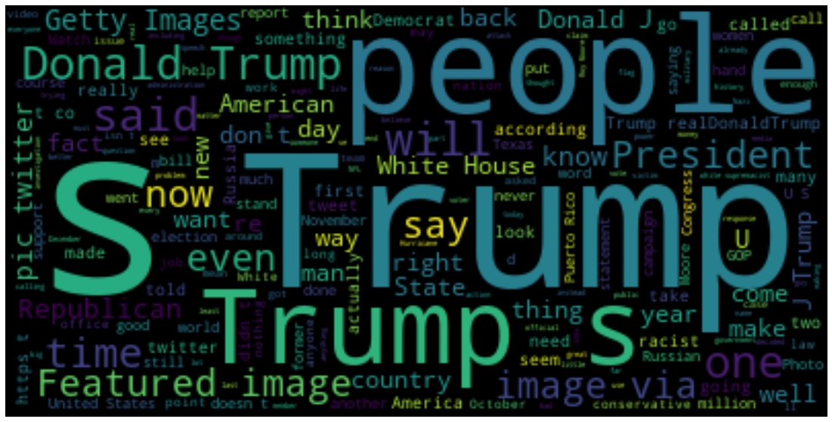  Figure 4 – Fake article significant terms  DATA PREP  Some of the samples were corrupted, but encoding in latin_1, and keeping only the first column of text was sufficient to clean the data for analysis.  Due to the large number of samples, the text was vectorized using a CountVectorizer, and a small data type, unsigned 8 bit integer, was used to store the count results. The number of features was set to 2000, stop words were removed, and bigrams were included during the vectorization process.  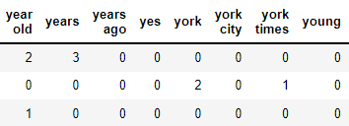  Figure 5 – Sample of vectorized text  Analysis METHODS  After vectorizing the articles, two classification models were trained. Once a prediction model is verified to be accurate, information about the significant features can be mined and insight can be gained into the decision process for determining misinformation.  For comparison purposes, both a Multinomial Naive Bayes (MNB) model, and a Support Vector Machine (SVM) model will be trained on the data.  Within the MNB model, the significant features are ranked by the likelihood ratio between false and true articles. The likelihood ratio can be derived from the individual probabilities of each feature for both the true and false classes.  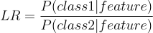  This is achieved by subtracting the logarithm of the probabilities for each feature.  To visualize the SVM model, the two most influential features will be plotted, and a slice of the hyperplane will be shown to divide the classes. This should demonstrate the margin between classes, as a measure of the difficulty of the classification decision.  Table 1 – Details of classification models
  Model | Parameters
  MNB | Default parameters
  SVM | Linear kernel
results  40/40 | technical results  The models were them trained and tested using 5-fold cross-validation. Additionally, the MNB model was tested against 40% reserved data to produce a confusion matrix. The cross-validation accuracy is given in table 2 below.  Unfortunately, due to the size of the dataset, the SVM model needed to be trained on a dense matrix instead of a sparse matrix. Because of this, only the cross-validation results are included for SVM, and the confusion matrix is omitted.  Both the Naive Bayes model and the Support Vector Machine achieved high accuracy.  Table 2 – Model accuracy results  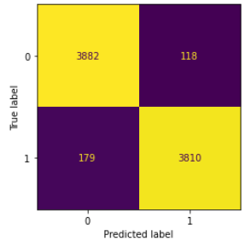  Figure 6 – MNB confusion matrix  Since the dataset is balanced, the accuracy of random guessing would be 50%. Both models achieved nearly 95% accuracy. Compared to random guessing, the models reduced the number of errors by a factor of 10. which is highly significant.  After establishing the high performance of the models, we can then gain insight into the decision process to learn about the features of misinformation.  MODEL INSIGHTS  The SVM model creates a hyperplane across all features which divides the classes into true and fake articles. The hyperplane maximizes the margin between the classes. A wider margin represents an easier decision, because there are fewer cases that fall close to the boundary between classes. With 2000 features, the hyperplane is highly dimensional, and needs to be reduced in order to be visualized.  By plotting the hyperplane against the 2 most important features, we can plot a slice of the hyperplane. See figure 7 below.  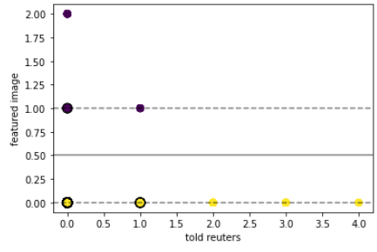  Figure 7 – Cross section of SVM hyperplane  In this case, the two most influential features were derived from the MNB model, which were the phrases “featured image” and “told reuters”. Since the features are vectorized by count, the SVM divides integer values of the phrases. As shown in figure 7, the samples are easily divided based on either 0 or 1 mentions of “featured image”. Each dot in the plot represents thousands of samples.  As described in the Analysis section of this paper, for the MNB model, we will examine the likelihood ratios of the features across both the true and fake classes.  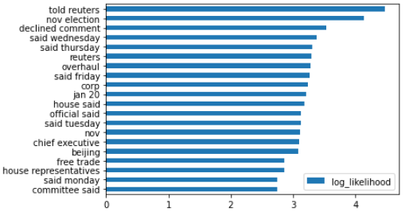  Figure – Feature likelihood ratios for Truth  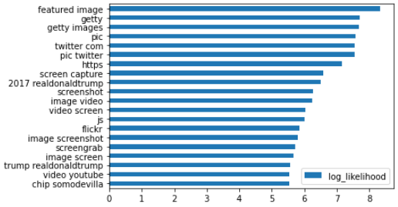  Figure – Feature likelihood ratio for Falsity  Many of the features correlated with true articles indicate that the source is from a speech or interview. For instance, these phrases indicate quoting:  - told reuters  - house said  - official said  - said monday  While features correlated with false articles indicate that the source is from an image or a tweet. For instance, these phrases indicate capturing images or tweets:  - twitter com  - pic twitter  - screen capture  - image screenshot  The result is easy to interpret. Articles which use sources from social media, or internet images, are likely to be fake, while articles which use publicly available quotes or speeches tend to be true.
  Model | Accuracy
  MNB | 94.50%
  SVM | 97.30%
conclusions  10/10 | In the modern environment of information overload, the public can't keep up with the amount of misinformation generated from sources all over the world. Bad actors might take advantage of the public's vulnerability to push propaganda and sway public opinion.  Mitigation efforts that have worked in the past are not nearly as effective. Fact-checking, debate, and critical thinking can't scale fast enough. The result is a populace that must lean on trusted sources to filter out misinformation. While this may work for broadcast news networks, who stake their reputation on their objectivity and accuracy, social media provides a side-channel for the proliferation of unfiltered information.    By using machine learning, we can provide new techniques to help the public find reliable sources and filter out misinformation. Social media platforms can automatically flag misleading posts, or detect propaganda bots and remove them from the platform.  While these automated models may quickly use thousands of clues to determine misleading information, we can still gain some insight into the process. According to the results of the analysis in this report, one strategy for determining if an article is genuine is to focus on the source of the information. Articles sourced from online images, screen captures, or social media tend to be misinformation, while articles sourced from publicly verifiable information, such as interview transcripts, press conferences, or statements released by the government, tend to be true.    By paying careful attention to sources, and leveraging automated tools in online platforms, users can regain trust in public discourse, reduce polarization, and improve community consensus on factual issues.

